Git Basics for Beginners


What is Git?
Git is a popular version control system.
It was created by Linus Torvalds in 2005, and has been maintained by Junio Hamano since then.
It is used for:
- Tracking code changes
- Tracking who made changes
- Coding collaboration

🚀 Git Basic Workflow

0. Initial git settings

git config -global user.name "your name"

git config -global user.email "your email"

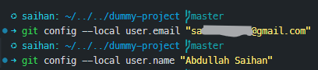

1. Start Git in your project
git init

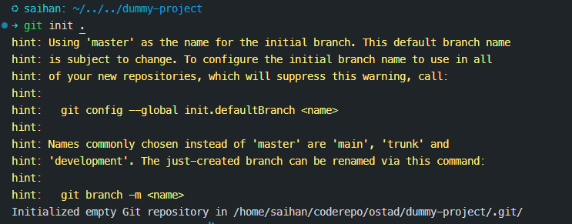
👉 This tells Git: “Start tracking this folder”

2. Create your file and start tracking it
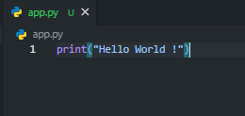
git status
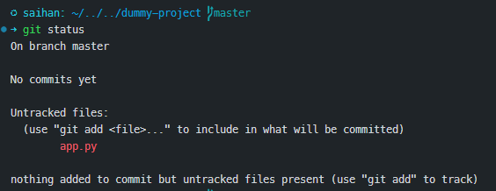
git add app.py

git status

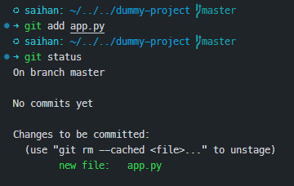
👉 git add means: “Hey Git, include this file in the next save”

3. ✅ First Commit (VERY IMPORTANT)
git commit -m "add app.py"
Or
git commit -m "initial commit"

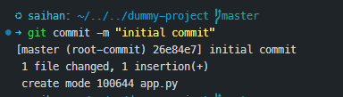
👉 This is your first saved version of the file
👉 Always commit right after you start tracking a file (good practice)

4. Make changes in your file
Edit app.py
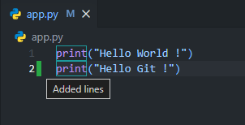
git status
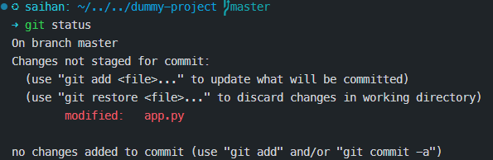
👉 Shows: file is modified (you changed something, but not saved yet)

5. Prepare updated changes
git add app.py

git status
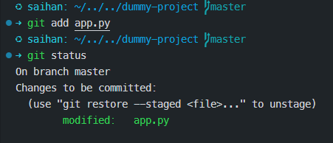

👉 Now your updated changes are ready to be saved

6. Save updated version
git commit -m "update app.py"
Or
git commit -m "add new line for greeting git"
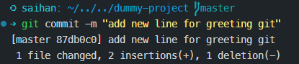
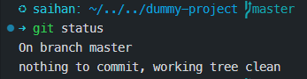
👉 Creates a new version with your latest changes

7. Check history
git log

git log --oneline


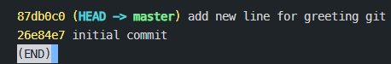
👉 Shows all versions

8. Go back to / check an old version
git checkout <commit_hash>

e.g.
git checkout 26e84e7
👉 Lets you see how your project looked before
Now get back to the current state
git checkout main

🌐 Push Code to GitHub

1. Create a repository on GitHub
👉 This is where your code will be stored online

2. Connect your project to GitHub
git remote add origin https://github.com/username/repository_name.git

👉 Links your local project with GitHub

3. Rename branch from master to main

git branch -M main

4. Push your code (first time)

git push -u origin main

👉 Uploads your project to GitHub

5. Next workflow (after changes)
git add .
git commit -m "your message"
git push

👉 Update your project online

🔥 Simple Daily Workflow
# change code
git add .
git commit -m "what you changed"
git push

⚡ Key Tips
- Always commit after adding new files first time
- Commit frequently (small updates)
- Write clear messages
- Use git status to stay aware

